|  |  |
| --- | --- |
|  | Foundation Activity 11 Voltage Divider Nightlight |

voltage Divider

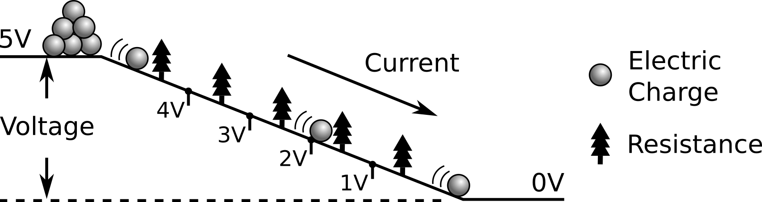

As **current** (moving electric charge) flows through a **resistance** (trees), **voltage** (height of the hill) is dropped. All of the voltage must be dropped across the resistors. As a circuit diagram, it looks like this:

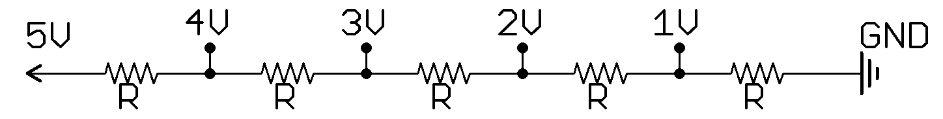

If all the resistors are the same, an equal amount of voltage is dropped across each one (1 V per resistor). The amount of voltage dropped across a resistor depends on how big its resistance is compared to the total resistance between 5V and 0V. Since the voltage is divided across the resistors, we call this a **voltage divider.**

|  |  |
| --- | --- |
|  | If we have one resistance of 2R, and another of 3R, more voltage will be dropped across the 3R resistor. |
|  | If we have two equal resistances, the voltage will be dropped equally across both of them (2.5V). |
|  | A Light Dependent Resistor (**LDR**) changes resistance depending the amount of light shining on it. **Vout** will change depending on the amount of light. |

Building a Nightlight Circuit

We can use an **LDR** in a voltage divider to make a night-light. If **Vout** is greater than 3 V the LED will be **ON**. If Vout is less than 3V, the LED turns **OFF**.

In this voltage divider, we have chosen R to have a resistance of 22 kΩ (22000 Ω). The other resistor (220 Ω) is usually used protect the LED from high current when powering it from 5V.

|  |  |
| --- | --- |
| C:\Users\Harryp\MEGA\Surface Pro 2\Nepal\Himalayan Makers Guild\Activities\Foundation Activities\FA11 - Voltage Divider Night Light\images\Eagle\nightlight_off.png | [[1]](#footnote-1)  When there is light, the LDR has a small resistance.  The LDR becomes much **less than** 22kΩ, so Vout drops **below** 3V and the LED turns **OFF**. |
| C:\Users\Harryp\MEGA\Surface Pro 2\Nepal\Himalayan Makers Guild\Activities\Foundation Activities\FA11 - Voltage Divider Night Light\images\Eagle\nightlight_on.png | When it is dark, the LDR has a big resistance.  The LDR much **greater than** 22kΩ, so Vout rises **above** 3V and the LED turns **ON**. |

How does the brightness of the LED compare to when we power it directly with 5V through the 220Ω resistor? What could be causing this difference?

1. Sun and moon icons made by Freepik from www.flaticon.com [↑](#footnote-ref-1)